LAPORAN TUGAS 1 TUTON
PEMROGRAMAN BERBASIS WEB
(STSI4209)



DISUSUN OLEH:
NAMA : I KD WIJAYA SASHMITHA ADHI C
NIM : 048068753
PRODI : SISTEM INFORMASI
FAKULTAS : SAINS DAN TEKNOLOGI
UT - DAERAH : DENPASAR

UNIVERSITAS TERBUKA
2026
- SOAL
Tujuan
Mahasiswa mampu mengimplementasikan konsep fundamental HTML, CSS, dan JavaScript DOM untuk membangun antarmuka dan alur interaktif dari aplikasi pemesanan bahan ajar SITTA untuk sistem kebutuhan proses pemesanan dan distribusi bahan ajar di UT.
Indikator hasil belajar:
• Mahasiswa dapat merancang struktur HTML yang semantik dan valid.
• Mahasiswa dapat mengelola gaya antarmuka menggunakan CSS (inline, internal, external).
• Mahasiswa dapat menggunakan JavaScript untuk manipulasi DOM, validasi form, manipulasi data tabel, dan interaksi UI sesuai kreativitas masing-masing seperti pop-up, modal box, dan alert box.
Soal Tugas
Anda diminta untuk membuat sebuah aplikasi website sederhana untuk pemesanan Bahan Ajar di Universitas Terbuka yang dilakukan oleh UT-Daerah. Pada tugas ini, mahasiswa berfokus pada proses Front-End tanpa menggunakan Back-End terlebih dahulu, sehingga data yang dibutuhkan tidak dibaca melalui database, tetapi melalui file js yang dilampirkan bersama Tugas Praktik ini. Buatlah empat halaman website sebagai berikut:
1. Halaman Login (login.html)
• Input: email dan password.
• Tombol "Login".
• Jika salah atau tidak sesuai, muncul pop-up/alert yang berisi "email/password yang anda masukkan salah".
• Terdapat tombol "Lupa Password" dan "Daftar" yang dimunculkan dalam modal box/pop up.
2. Dashboard Menu (dashboard.html)
• Menu utama berupa tombol navigasi ke: Informasi Bahan Ajar, Tracking Pengiriman, Laporan (Monitoring Progress DO Bahan Ajar, Rekap Bahan Ajar), dan Histori Transaksi Bahan Ajar.
• Tampilkan "greeting" berdasarkan waktu local time (pagi/siang/sore).
3. Tracking Pengiriman (tracking.html)
• Input: Nomor Delivery Order.
• Ketika tombol "Cari" ditekan, tampilkan: Nama Mahasiswa; Status Pengiriman (dapat disimulasikan dengan progress bar, warna, tabel, atau list); detail ekspedisi, tanggal kirim, jenis paket, total pembayaran.
4. Informasi Stok Bahan Ajar (stok.html)
• Menampilkan secara dinamis data dummy pada data.js di variable konstanta dataBahanAjar.
• Terdapat fitur untuk menambahkan baris stok baru menggunakan JavaScript DOM.
Struktur folder proyek: index.html (halaman login), dashboard.html, tracking.html, stok.html, css/style.css, js/script.js, assets/ (logo-ut.png opsional). Data dummy disimpan dalam folder js.
Kriteria Penilaian
No | Kriteria | Poin
1.1 | Struktur HTML yang semantik, valid, dan lengkap | 15
1.2 | Desain CSS | 15
1.3 | JavaScript DOM (interaktivitas dan manipulasi data) | 25
1.4 | Validasi Form & Alert (feedback saat error) | 15
1.5 | Modularitas File dan Struktur File | 5
1.6 | Kreativitas tambahan (tema, fitur, UI) | 10
1.7 | Penjelasan dalam video (sistematika, alur berpikir, argumentasi) | 15

Durasi video penjelasan maksimal 15 menit.
- Program
Aplikasi dibuat dengan HTML, CSS, dan JavaScript murni (tanpa framework), memakai VS Code. Cara menjalankan: buka index.html di browser, atau jalankan server lokal npx serve . di folder sitta-praktik. Akun demo: rina@ut.ac.id / rina123 dan admin@ut.ac.id / admin123. Nomor DO contoh: 2023001234 dan 2023005678.
Struktur folder:
sitta-praktik/
├── index.html halaman login
├── dashboard.html menu utama + greeting
├── tracking.html tracking Delivery Order
├── stok.html informasi stok bahan ajar
├── css/style.css stylesheet eksternal
├── js/data.js data dummy (dataPengguna, dataBahanAjar, dataTracking)
├── js/script.js logika DOM semua halaman
└── assets/img/ cover bahan ajar

Kode lengkap css/style.css (848 baris) ada di file source code yang dikumpulkan; cuplikannya ada di bagian Penjelasan program.
index.html
<!DOCTYPE html>
<html lang="id">
<head>
<meta charset="UTF-8" />
<meta name="viewport" content="width=device-width, initial-scale=1.0" />
<meta name="description" content="Login SITTA - Sistem Informasi Tiras dan Transaksi Bahan Ajar Universitas Terbuka" />
<title>Login | SITTA Universitas Terbuka</title>
<link rel="preconnect" href="https://fonts.googleapis.com" />
<link href="https://fonts.googleapis.com/css2?family=Poppins:wght@400;600;700&display=swap" rel="stylesheet" />
<link rel="stylesheet" href="https://cdn.jsdelivr.net/npm/bootstrap-icons@1.11.3/font/bootstrap-icons.min.css" />
<link rel="stylesheet" href="css/style.css" />
</head>
<body class="login-page" data-page="login">
<main class="login-card">
<header>
<div class="brand">
<span class="brand-logo"><i class="bi bi-book-half" aria-hidden="true"></i></span>
<span>SITTA <small style="font-weight: 400; color: #6b7280">Universitas Terbuka</small></span>
</div>
<h1>Selamat Datang</h1>
<p class="subtitle">Masuk untuk mengelola pemesanan bahan ajar.</p>
</header>

<form id="loginForm" novalidate>
<div class="form-group">
<label for="email">Email</label>
<div class="input-icon">
<i class="bi bi-envelope-fill" aria-hidden="true"></i>
<input type="email" id="email" name="email" placeholder="nama@ut.ac.id" autocomplete="email" />
</div>
<small class="error-text" id="emailError"></small>
</div>

<div class="form-group">
<label for="password">Password</label>
<div class="input-icon">
<i class="bi bi-key-fill" aria-hidden="true"></i>
<input type="password" id="password" name="password" placeholder="Password" autocomplete="current-password" />
</div>
<small class="error-text" id="passwordError"></small>
</div>

<p class="forgot-row">
<button type="button" class="btn-link" data-modal-open="forgotModal">Lupa password?</button>
</p>

<button type="submit" class="btn btn-primary btn-block">
<i class="bi bi-box-arrow-in-right" aria-hidden="true"></i> Masuk
</button>
</form>

<p class="register-row">
Belum punya akun?
<button type="button" class="btn-link" data-modal-open="registerModal">Daftar</button>
</p>

<aside class="demo-hint">
<strong>Akun demo:</strong> rina@ut.ac.id / rina123 &middot; admin@ut.ac.id / admin123
</aside>
</main>

<!-- Modal: login gagal -->
<div class="modal" id="loginErrorModal" role="dialog" aria-modal="true" aria-labelledby="loginErrorTitle">
<div class="modal-content modal-alert">
<i class="bi bi-x-circle-fill alert-icon" aria-hidden="true"></i>
<h2 id="loginErrorTitle">Login Gagal</h2>
<p>Email/password yang anda masukkan salah.</p>
<button type="button" class="btn btn-secondary" data-modal-close>Coba Lagi</button>
</div>
</div>

<!-- Modal: lupa password -->
<div class="modal" id="forgotModal" role="dialog" aria-modal="true" aria-labelledby="forgotTitle">
<div class="modal-content">
<div class="modal-header">
<h2 id="forgotTitle">Lupa Password</h2>
<button type="button" class="modal-close" data-modal-close aria-label="Tutup">&times;</button>
</div>
<p style="color: #6b7280; margin-bottom: 1rem">Masukkan email terdaftar, tautan reset password akan dikirim.</p>
<form id="forgotForm" novalidate>
<div class="form-group">
<label for="forgotEmail">Email</label>
<input type="email" id="forgotEmail" placeholder="nama@ut.ac.id" />
<small class="error-text" id="forgotEmailError"></small>
</div>
<div class="modal-actions">
<button type="button" class="btn btn-outline" data-modal-close>Batal</button>
<button type="submit" class="btn btn-primary">Kirim</button>
</div>
</form>
</div>
</div>

<!-- Modal: daftar -->
<div class="modal" id="registerModal" role="dialog" aria-modal="true" aria-labelledby="registerTitle">
<div class="modal-content">
<div class="modal-header">
<h2 id="registerTitle">Daftar Akun</h2>
<button type="button" class="modal-close" data-modal-close aria-label="Tutup">&times;</button>
</div>
<form id="registerForm" novalidate>
<div class="form-group">
<label for="regNama">Nama Lengkap</label>
<input type="text" id="regNama" placeholder="Nama lengkap" />
<small class="error-text" id="regNamaError"></small>
</div>
<div class="form-group">
<label for="regEmail">Email</label>
<input type="email" id="regEmail" placeholder="nama@ut.ac.id" />
<small class="error-text" id="regEmailError"></small>
</div>
<div class="form-group">
<label for="regRole">Unit</label>
<select id="regRole">
<option value="">-- Pilih unit --</option>
<option>UPBJJ-UT</option>
<option>Puslaba</option>
<option>Fakultas</option>
</select>
<small class="error-text" id="regRoleError"></small>
</div>
<div class="form-group">
<label for="regPassword">Password</label>
<input type="password" id="regPassword" placeholder="Minimal 6 karakter" />
<small class="error-text" id="regPasswordError"></small>
</div>
<div class="modal-actions">
<button type="button" class="btn btn-outline" data-modal-close>Batal</button>
<button type="submit" class="btn btn-primary">Daftar</button>
</div>
</form>
</div>
</div>

<div class="toast-container" id="toastContainer" aria-live="polite"></div>

<script src="js/data.js"></script>
<script src="js/script.js"></script>
</body>
</html>

dashboard.html
<!DOCTYPE html>
<html lang="id">
<head>
<meta charset="UTF-8" />
<meta name="viewport" content="width=device-width, initial-scale=1.0" />
<meta name="description" content="Dashboard SITTA - menu utama pemesanan dan distribusi bahan ajar UT" />
<title>Dashboard | SITTA Universitas Terbuka</title>
<link rel="preconnect" href="https://fonts.googleapis.com" />
<link href="https://fonts.googleapis.com/css2?family=Poppins:wght@400;600;700&display=swap" rel="stylesheet" />
<link rel="stylesheet" href="https://cdn.jsdelivr.net/npm/bootstrap-icons@1.11.3/font/bootstrap-icons.min.css" />
<link rel="stylesheet" href="css/style.css" />
</head>
<body data-page="dashboard">
<header class="navbar">
<nav class="container" aria-label="Navigasi utama">
<a href="dashboard.html" class="brand">
<span class="brand-logo"><i class="bi bi-book-half" aria-hidden="true"></i></span>
SITTA
</a>
<button type="button" class="nav-toggle" id="navToggle" aria-label="Buka menu" aria-expanded="false">
<i class="bi bi-list"></i>
</button>
<ul class="nav-menu" id="navMenu">
<li><a href="stok.html" class="nav-link"><i class="bi bi-journal-bookmark"></i> Informasi Bahan Ajar</a></li>
<li><a href="tracking.html" class="nav-link"><i class="bi bi-truck"></i> Tracking Pengiriman</a></li>
<li class="dropdown">
<button type="button" class="nav-link" aria-haspopup="true" aria-expanded="false">
<i class="bi bi-bar-chart-line"></i> Laporan <i class="bi bi-chevron-down"></i>
</button>
<ul class="dropdown-menu">
<li><a href="#" data-coming-soon="Monitoring Progress DO Bahan Ajar"><i class="bi bi-clipboard-data"></i> Monitoring Progress DO Bahan Ajar</a></li>
<li><a href="#" data-coming-soon="Rekap Bahan Ajar"><i class="bi bi-file-earmark-bar-graph"></i> Rekap Bahan Ajar</a></li>
</ul>
</li>
<li><a href="#" class="nav-link" data-coming-soon="Histori Transaksi Bahan Ajar"><i class="bi bi-clock-history"></i> Histori Transaksi Bahan Ajar</a></li>
<li><a href="index.html" class="nav-link" data-logout><i class="bi bi-box-arrow-right"></i> Keluar</a></li>
</ul>
</nav>
</header>

<main class="container">
<section class="hero" aria-labelledby="greeting">
<div>
<p style="opacity: 0.8">Dashboard Aplikasi SITTA</p>
<h1 id="greeting">Selamat datang</h1>
<p id="todayDate" style="opacity: 0.8"></p>
</div>
<div class="clock" id="clock" aria-label="Jam saat ini">--:--:--</div>
</section>

<section class="stats" aria-label="Ringkasan data">
<article class="stat-card">
<span class="icon"><i class="bi bi-journals"></i></span>
<div>
<div class="value" id="statJudul">0</div>
<div class="label">Judul Bahan Ajar</div>
</div>
</article>
<article class="stat-card">
<span class="icon"><i class="bi bi-box-seam"></i></span>
<div>
<div class="value" id="statStok">0</div>
<div class="label">Total Stok (eksemplar)</div>
</div>
</article>
<article class="stat-card">
<span class="icon"><i class="bi bi-truck"></i></span>
<div>
<div class="value" id="statDO">0</div>
<div class="label">Delivery Order Aktif</div>
</div>
</article>
</section>

<section class="card" aria-labelledby="menuTitle">
<h2 id="menuTitle" style="margin-bottom: 1rem; font-size: 1.15rem">Menu Utama</h2>
<div class="menu-grid">
<a href="stok.html" class="menu-card">
<i class="bi bi-journal-bookmark"></i>
<h3>Informasi Bahan Ajar</h3>
<p>Lihat dan tambah data stok bahan ajar.</p>
</a>
<a href="tracking.html" class="menu-card">
<i class="bi bi-truck"></i>
<h3>Tracking Pengiriman</h3>
<p>Lacak status Delivery Order.</p>
</a>
<button type="button" class="menu-card" data-coming-soon="Laporan">
<i class="bi bi-bar-chart-line"></i>
<h3>Laporan</h3>
<p>Monitoring progress DO &amp; rekap bahan ajar.</p>
</button>
<button type="button" class="menu-card" data-coming-soon="Histori Transaksi Bahan Ajar">
<i class="bi bi-clock-history"></i>
<h3>Histori Transaksi</h3>
<p>Riwayat transaksi bahan ajar.</p>
</button>
</div>
</section>
</main>

<footer class="footer">&copy; 2026 SITTA &middot; Universitas Terbuka</footer>

<div class="toast-container" id="toastContainer" aria-live="polite"></div>

<script src="js/data.js"></script>
<script src="js/script.js"></script>
</body>
</html>

tracking.html
<!DOCTYPE html>
<html lang="id">
<head>
<meta charset="UTF-8" />
<meta name="viewport" content="width=device-width, initial-scale=1.0" />
<meta name="description" content="Tracking pengiriman bahan ajar SITTA berdasarkan nomor Delivery Order" />
<title>Tracking Pengiriman | SITTA Universitas Terbuka</title>
<link rel="preconnect" href="https://fonts.googleapis.com" />
<link href="https://fonts.googleapis.com/css2?family=Poppins:wght@400;600;700&display=swap" rel="stylesheet" />
<link rel="stylesheet" href="https://cdn.jsdelivr.net/npm/bootstrap-icons@1.11.3/font/bootstrap-icons.min.css" />
<link rel="stylesheet" href="css/style.css" />
<style>
.search-form {
display: flex;
gap: 0.6rem;
flex-wrap: wrap;
}

.search-form .input-icon {
flex: 1;
min-width: 220px;
}

.sample-do {
margin-top: 0.8rem;
font-size: 0.85rem;
color: var(--muted);
}

.sample-do button {
margin-left: 0.3rem;
}

.do-header {
background: linear-gradient(120deg, var(--navy), var(--navy-light));
color: #fff;
border-radius: var(--radius);
padding: 1.4rem;
display: flex;
justify-content: space-between;
flex-wrap: wrap;
gap: 1rem;
}

.do-header h2 {
font-size: 1.2rem;
text-transform: uppercase;
}

.do-header .do-number {
font-size: 1.1rem;
letter-spacing: 1px;
opacity: 0.9;
}

.progress {
margin: 1.5rem 0 0.5rem;
height: 10px;
background: var(--border);
border-radius: 999px;
overflow: hidden;
}

.progress-bar {
height: 100%;
width: 0;
background: var(--yellow);
transition: width 0.8s ease;
}

.progress-bar.done {
background: var(--success);
}

.steps {
display: grid;
grid-template-columns: repeat(4, 1fr);
text-align: center;
font-size: 0.8rem;
color: var(--muted);
}

.steps li {
list-style: none;
}

.steps li.reached {
color: var(--navy);
font-weight: 600;
}

.steps i {
display: block;
font-size: 1.3rem;
}

.detail-grid {
display: grid;
grid-template-columns: repeat(auto-fit, minmax(180px, 1fr));
gap: 1rem;
margin: 1.5rem 0;
}

.detail-grid dt {
font-size: 0.8rem;
color: var(--muted);
}

.detail-grid dd {
font-weight: 600;
}

.timeline {
list-style: none;
border-left: 3px solid var(--border);
margin-left: 0.5rem;
}

.timeline li {
position: relative;
padding: 0 0 1.2rem 1.4rem;
display: flex;
justify-content: space-between;
gap: 1rem;
flex-wrap: wrap;
}

.timeline li::before {
content: "";
position: absolute;
left: -9px;
top: 4px;
width: 15px;
height: 15px;
border-radius: 50%;
background: var(--yellow);
border: 3px solid #fff;
box-shadow: 0 0 0 1px var(--yellow);
}

.timeline li:first-child::before {
background: var(--navy);
box-shadow: 0 0 0 1px var(--navy);
}

.timeline time {
color: var(--muted);
font-size: 0.85rem;
white-space: nowrap;
}
</style>
</head>
<body data-page="tracking">
<header class="navbar">
<nav class="container" aria-label="Navigasi utama">
<a href="dashboard.html" class="brand">
<span class="brand-logo"><i class="bi bi-book-half" aria-hidden="true"></i></span>
SITTA
</a>
<button type="button" class="nav-toggle" id="navToggle" aria-label="Buka menu" aria-expanded="false">
<i class="bi bi-list"></i>
</button>
<ul class="nav-menu" id="navMenu">
<li><a href="stok.html" class="nav-link"><i class="bi bi-journal-bookmark"></i> Informasi Bahan Ajar</a></li>
<li><a href="tracking.html" class="nav-link active" aria-current="page"><i class="bi bi-truck"></i> Tracking Pengiriman</a></li>
<li class="dropdown">
<button type="button" class="nav-link" aria-haspopup="true" aria-expanded="false">
<i class="bi bi-bar-chart-line"></i> Laporan <i class="bi bi-chevron-down"></i>
</button>
<ul class="dropdown-menu">
<li><a href="#" data-coming-soon="Monitoring Progress DO Bahan Ajar"><i class="bi bi-clipboard-data"></i> Monitoring Progress DO Bahan Ajar</a></li>
<li><a href="#" data-coming-soon="Rekap Bahan Ajar"><i class="bi bi-file-earmark-bar-graph"></i> Rekap Bahan Ajar</a></li>
</ul>
</li>
<li><a href="#" class="nav-link" data-coming-soon="Histori Transaksi Bahan Ajar"><i class="bi bi-clock-history"></i> Histori Transaksi Bahan Ajar</a></li>
<li><a href="index.html" class="nav-link" data-logout><i class="bi bi-box-arrow-right"></i> Keluar</a></li>
</ul>
</nav>
</header>

<main class="container">
<section class="page-header">
<h1>Tracking Pengiriman</h1>
<p>Lacak status pengiriman bahan ajar berdasarkan nomor Delivery Order (DO).</p>
</section>

<section class="card" aria-label="Form pencarian DO">
<form id="trackingForm" class="search-form" novalidate>
<div class="input-icon">
<i class="bi bi-upc-scan" aria-hidden="true"></i>
<input type="text" id="nomorDO" inputmode="numeric" placeholder="Masukkan Nomor Delivery Order" aria-label="Nomor Delivery Order" />
</div>
<button type="submit" class="btn btn-primary"><i class="bi bi-search"></i> Cari</button>
</form>
<small class="error-text" id="nomorDOError"></small>
<p class="sample-do">
Contoh DO:
<button type="button" class="btn-link" data-sample-do="2023001234">2023001234</button>
<button type="button" class="btn-link" data-sample-do="2023005678">2023005678</button>
</p>
</section>

<section id="trackingResult" class="card" hidden aria-live="polite"></section>
</main>

<footer class="footer">&copy; 2026 SITTA &middot; Universitas Terbuka</footer>

<div class="toast-container" id="toastContainer" aria-live="polite"></div>

<script src="js/data.js"></script>
<script src="js/script.js"></script>
</body>
</html>

stok.html
<!DOCTYPE html>
<html lang="id">
<head>
<meta charset="UTF-8" />
<meta name="viewport" content="width=device-width, initial-scale=1.0" />
<meta name="description" content="Informasi stok bahan ajar SITTA Universitas Terbuka" />
<title>Informasi Bahan Ajar | SITTA Universitas Terbuka</title>
<link rel="preconnect" href="https://fonts.googleapis.com" />
<link href="https://fonts.googleapis.com/css2?family=Poppins:wght@400;600;700&display=swap" rel="stylesheet" />
<link rel="stylesheet" href="https://cdn.jsdelivr.net/npm/bootstrap-icons@1.11.3/font/bootstrap-icons.min.css" />
<link rel="stylesheet" href="css/style.css" />
</head>
<body data-page="stok">
<header class="navbar">
<nav class="container" aria-label="Navigasi utama">
<a href="dashboard.html" class="brand">
<span class="brand-logo"><i class="bi bi-book-half" aria-hidden="true"></i></span>
SITTA
</a>
<button type="button" class="nav-toggle" id="navToggle" aria-label="Buka menu" aria-expanded="false">
<i class="bi bi-list"></i>
</button>
<ul class="nav-menu" id="navMenu">
<li><a href="stok.html" class="nav-link active" aria-current="page"><i class="bi bi-journal-bookmark"></i> Informasi Bahan Ajar</a></li>
<li><a href="tracking.html" class="nav-link"><i class="bi bi-truck"></i> Tracking Pengiriman</a></li>
<li class="dropdown">
<button type="button" class="nav-link" aria-haspopup="true" aria-expanded="false">
<i class="bi bi-bar-chart-line"></i> Laporan <i class="bi bi-chevron-down"></i>
</button>
<ul class="dropdown-menu">
<li><a href="#" data-coming-soon="Monitoring Progress DO Bahan Ajar"><i class="bi bi-clipboard-data"></i> Monitoring Progress DO Bahan Ajar</a></li>
<li><a href="#" data-coming-soon="Rekap Bahan Ajar"><i class="bi bi-file-earmark-bar-graph"></i> Rekap Bahan Ajar</a></li>
</ul>
</li>
<li><a href="#" class="nav-link" data-coming-soon="Histori Transaksi Bahan Ajar"><i class="bi bi-clock-history"></i> Histori Transaksi Bahan Ajar</a></li>
<li><a href="index.html" class="nav-link" data-logout><i class="bi bi-box-arrow-right"></i> Keluar</a></li>
</ul>
</nav>
</header>

<main class="container">
<section class="page-header">
<h1>Informasi Bahan Ajar</h1>
<p>Peragaan data stok bahan ajar di setiap lokasi.</p>
</section>

<section class="card" aria-label="Tabel stok bahan ajar">
<div class="toolbar">
<div class="input-icon">
<i class="bi bi-search" aria-hidden="true"></i>
<input type="search" id="searchStok" placeholder="Cari kode / nama bahan ajar..." aria-label="Cari bahan ajar" />
</div>
<button type="button" class="btn btn-primary" data-modal-open="addStokModal">
<i class="bi bi-plus-lg"></i> Tambah Stok
</button>
</div>

<div class="table-wrap">
<table>
<thead>
<tr>
<th scope="col">No</th>
<th scope="col">Cover</th>
<th scope="col">Kode Lokasi</th>
<th scope="col">Kode Barang</th>
<th scope="col">Nama Barang</th>
<th scope="col">Jenis</th>
<th scope="col">Edisi</th>
<th scope="col" style="text-align: right">Stok</th>
</tr>
</thead>
<tbody id="stokTableBody"></tbody>
</table>
</div>
<p class="table-footer" id="stokSummary"></p>
</section>
</main>

<!-- Modal: tambah stok -->
<div class="modal" id="addStokModal" role="dialog" aria-modal="true" aria-labelledby="addStokTitle">
<div class="modal-content wide">
<div class="modal-header">
<h2 id="addStokTitle">Tambah Stok Bahan Ajar</h2>
<button type="button" class="modal-close" data-modal-close aria-label="Tutup">&times;</button>
</div>
<form id="addStokForm" novalidate>
<div class="form-row">
<div class="form-group">
<label for="kodeLokasi">Kode Lokasi</label>
<input type="text" id="kodeLokasi" placeholder="cth. 0JKT01" />
<small class="error-text" id="kodeLokasiError"></small>
</div>
<div class="form-group">
<label for="kodeBarang">Kode Barang</label>
<input type="text" id="kodeBarang" placeholder="cth. SATS4121" />
<small class="error-text" id="kodeBarangError"></small>
</div>
</div>
<div class="form-group">
<label for="namaBarang">Nama Barang</label>
<input type="text" id="namaBarang" placeholder="Judul bahan ajar" />
<small class="error-text" id="namaBarangError"></small>
</div>
<div class="form-row">
<div class="form-group">
<label for="jenisBarang">Jenis Barang</label>
<select id="jenisBarang">
<option value="">-- Pilih jenis --</option>
<option>BMP</option>
<option>Modul Praktikum</option>
<option>Buku Pendukung</option>
</select>
<small class="error-text" id="jenisBarangError"></small>
</div>
<div class="form-group">
<label for="edisi">Edisi</label>
<input type="number" id="edisi" min="1" placeholder="cth. 1" />
<small class="error-text" id="edisiError"></small>
</div>
</div>
<div class="form-group">
<label for="stok">Jumlah Stok</label>
<input type="number" id="stok" min="0" placeholder="cth. 100" />
<small class="error-text" id="stokError"></small>
</div>
<div class="modal-actions">
<button type="button" class="btn btn-outline" data-modal-close>Batal</button>
<button type="submit" class="btn btn-primary"><i class="bi bi-save"></i> Simpan</button>
</div>
</form>
</div>
</div>

<footer class="footer">&copy; 2026 SITTA &middot; Universitas Terbuka</footer>

<div class="toast-container" id="toastContainer" aria-live="polite"></div>

<script src="js/data.js"></script>
<script src="js/script.js"></script>
</body>
</html>

js/data.js
var dataPengguna = [
{
id: 1,
nama: "Rina Wulandari",
email: "rina@ut.ac.id",
password: "rina123",
role: "UPBJJ-UT",
lokasi: "UPBJJ Jakarta",
},
{
id: 2,
nama: "Agus Pranoto",
email: "agus@ut.ac.id",
password: "agus123",
role: "UPBJJ-UT",
lokasi: "UPBJJ Makassar",
},
{
id: 3,
nama: "Siti Marlina",
email: "siti@ut.ac.id",
password: "siti123",
role: "Puslaba",
lokasi: "Pusat",
},
{
id: 4,
nama: "Doni Setiawan",
email: "doni@ut.ac.id",
password: "doni123",
role: "Fakultas",
lokasi: "FISIP",
},
{
id: 5,
nama: "Admin SITTA",
email: "admin@ut.ac.id",
password: "admin123",
role: "Administrator",
lokasi: "Pusat",
},
];

var dataBahanAjar = [
{
kodeLokasi: "0TMP01",
kodeBarang: "ASIP4301",
namaBarang: "Pengantar Ilmu Komunikasi",
jenisBarang: "BMP",
edisi: "2",
stok: 548,
cover: "assets/img/pengantar_komunikasi.jpg",
},
{
kodeLokasi: "0JKT01",
kodeBarang: "EKMA4216",
namaBarang: "Manajemen Keuangan",
jenisBarang: "BMP",
edisi: "3",
stok: 392,
cover: "assets/img/manajemen_keuangan.jpg",
},
{
kodeLokasi: "0SBY02",
kodeBarang: "EKMA4310",
namaBarang: "Kepemimpinan",
jenisBarang: "BMP",
edisi: "1",
stok: 278,
cover: "assets/img/kepemimpinan.jpg",
},
{
kodeLokasi: "0MLG01",
kodeBarang: "BIOL4211",
namaBarang: "Mikrobiologi Dasar",
jenisBarang: "BMP",
edisi: "2",
stok: 165,
cover: "assets/img/mikrobiologi.jpg",
},
{
kodeLokasi: "0UPBJJBDG",
kodeBarang: "PAUD4401",
namaBarang: "Perkembangan Anak Usia Dini",
jenisBarang: "BMP",
edisi: "4",
stok: 204,
cover: "assets/img/paud_perkembangan.jpeg",
},
];

var dataTracking = {
2023001234: {
nomorDO: "2023001234",
nama: "Rina Wulandari",
status: "Dalam Perjalanan",
ekspedisi: "JNE",
tanggalKirim: "2025-08-25",
paket: "0JKT01",
total: "Rp 180.000",
perjalanan: [
{
waktu: "2025-08-25 10:12:20",
keterangan: "Penerimaan di Loket: TANGERANG SELATAN. Pengirim: Universitas Terbuka",
},
{
waktu: "2025-08-25 14:07:56",
keterangan: "Tiba di Hub: TANGERANG SELATAN",
},
{
waktu: "2025-08-25 16:45:10",
keterangan: "Diteruskan ke Kantor Jakarta Selatan",
},
],
},
2023005678: {
nomorDO: "2023005678",
nama: "Agus Pranoto",
status: "Selesai",
ekspedisi: "Pos Indonesia",
tanggalKirim: "2025-08-25",
paket: "0UPBJJBDG",
total: "Rp 220.000",
perjalanan: [
{
waktu: "2025-08-25 10:12:20",
keterangan: "Penerimaan di Loket: TANGERANG SELATAN. Pengirim: Universitas Terbuka",
},
{
waktu: "2025-08-25 14:07:56",
keterangan: "Tiba di Hub: TANGERANG SELATAN",
},
{
waktu: "2025-08-25 16:30:10",
keterangan: "Diteruskan ke Kantor Kota Bandung",
},
{
waktu: "2025-08-26 12:15:33",
keterangan: "Tiba di Hub: Kota BANDUNG",
},
{
waktu: "2025-08-26 15:06:12",
keterangan: "Proses antar ke Cimahi",
},
{
waktu: "2025-08-26 20:00:00",
keterangan: "Selesai Antar. Penerima: Agus Pranoto",
},
],
},
};

js/script.js
/* ==========================================================
SITTA — script utama (manipulasi DOM, validasi, interaksi UI)
Data dummy dari js/data.js: dataPengguna, dataBahanAjar, dataTracking
========================================================== */

/* ---------- Utilitas umum ---------- */

const EMAIL_PATTERN = /^[^\s@]+@[^\s@]+\.[^\s@]+$/;

function $(selector) {
return document.querySelector(selector);
}

function escapeHtml(text) {
const div = document.createElement("div");
div.textContent = String(text);
return div.innerHTML;
}

function formatAngka(angka) {
return Number(angka).toLocaleString("id-ID");
}

/* ---------- Toast notification ---------- */

const TOAST_ICONS = {
success: "bi-check-circle-fill",
error: "bi-x-circle-fill",
warning: "bi-exclamation-triangle-fill",
info: "bi-info-circle-fill",
};

function showToast(message, type = "info") {
const container = $("#toastContainer");
if (!container) return;

const toast = document.createElement("div");
toast.className = `toast toast-${type}`;
toast.setAttribute("role", type === "error" ? "alert" : "status");

const icon = document.createElement("i");
icon.className = `bi ${TOAST_ICONS[type]}`;
const text = document.createElement("span");
text.textContent = message;
toast.append(icon, text);

container.appendChild(toast);
setTimeout(() => {
toast.classList.add("hide");
toast.addEventListener("animationend", () => toast.remove());
}, 3000);
}

/* ---------- Modal ---------- */

function openModal(id) {
const modal = document.getElementById(id);
if (!modal) return;
modal.classList.add("show");
const firstInput = modal.querySelector("input, select, button");
if (firstInput) firstInput.focus();
}

function closeModal(modal) {
modal.classList.remove("show");
const form = modal.querySelector("form");
if (form) resetForm(form);
}

function initModals() {
document.querySelectorAll("[data-modal-open]").forEach((btn) => {
btn.addEventListener("click", () => openModal(btn.dataset.modalOpen));
});

document.querySelectorAll(".modal").forEach((modal) => {
modal.addEventListener("click", (e) => {
if (e.target === modal || e.target.closest("[data-modal-close]")) {
closeModal(modal);
}
});
});

document.addEventListener("keydown", (e) => {
if (e.key !== "Escape") return;
document.querySelectorAll(".modal.show").forEach(closeModal);
});
}

/* ---------- Validasi form ---------- */

function setError(input, message) {
const errorEl = document.getElementById(`${input.id}Error`);
input.classList.toggle("is-invalid", Boolean(message));
input.setAttribute("aria-invalid", Boolean(message));
if (errorEl) errorEl.textContent = message || "";
return !message;
}

function resetForm(form) {
form.reset();
form.querySelectorAll("input, select").forEach((input) => setError(input, ""));
}

function validateEmail(input) {
const value = input.value.trim();
if (!value) return setError(input, "Email wajib diisi.");
if (!EMAIL_PATTERN.test(value)) return setError(input, "Format email tidak valid.");
return setError(input, "");
}

function validateRequired(input, label) {
if (!input.value.trim()) return setError(input, `${label} wajib diisi.`);
return setError(input, "");
}

function clearErrorOnInput(form) {
form.querySelectorAll("input, select").forEach((input) => {
input.addEventListener("input", () => setError(input, ""));
});
}

/* ---------- Navbar (semua halaman setelah login) ---------- */

function initNavbar() {
const toggle = $("#navToggle");
const menu = $("#navMenu");
if (!toggle || !menu) return;

toggle.addEventListener("click", () => {
const isOpen = menu.classList.toggle("open");
toggle.setAttribute("aria-expanded", isOpen);
toggle.querySelector("i").className = isOpen ? "bi bi-x-lg" : "bi bi-list";
});

document.querySelectorAll(".dropdown").forEach((dropdown) => {
const trigger = dropdown.querySelector("button");
trigger.addEventListener("click", (e) => {
e.stopPropagation();
const isOpen = dropdown.classList.toggle("open");
trigger.setAttribute("aria-expanded", isOpen);
});
});

document.addEventListener("click", () => {
document.querySelectorAll(".dropdown.open").forEach((d) => {
d.classList.remove("open");
d.querySelector("button").setAttribute("aria-expanded", "false");
});
});

document.querySelectorAll("[data-coming-soon]").forEach((el) => {
el.addEventListener("click", (e) => {
e.preventDefault();
showToast(`Fitur "${el.dataset.comingSoon}" segera hadir.`, "info");
});
});

document.querySelectorAll("[data-logout]").forEach((el) => {
el.addEventListener("click", (e) => {
if (!confirm("Yakin ingin keluar dari SITTA?")) e.preventDefault();
});
});
}

/* ==========================================================
Halaman Login (index.html)
========================================================== */

function initLoginPage() {
const form = $("#loginForm");
const email = $("#email");
const password = $("#password");
clearErrorOnInput(form);

form.addEventListener("submit", (e) => {
e.preventDefault();
const emailValid = validateEmail(email);
const passwordValid = validateRequired(password, "Password");
if (!emailValid || !passwordValid) return;

const user = dataPengguna.find(
(u) => u.email === email.value.trim().toLowerCase() && u.password === password.value
);

if (!user) {
openModal("loginErrorModal");
return;
}

showToast(`Login berhasil. Selamat datang, ${user.nama}!`, "success");
setTimeout(() => (window.location.href = "dashboard.html"), 900);
});

const forgotForm = $("#forgotForm");
clearErrorOnInput(forgotForm);
forgotForm.addEventListener("submit", (e) => {
e.preventDefault();
const input = $("#forgotEmail");
if (!validateEmail(input)) return;

const terdaftar = dataPengguna.some((u) => u.email === input.value.trim().toLowerCase());
if (!terdaftar) {
setError(input, "Email tidak terdaftar.");
return;
}
closeModal($("#forgotModal"));
showToast("Tautan reset password telah dikirim ke email Anda.", "success");
});

const registerForm = $("#registerForm");
clearErrorOnInput(registerForm);
registerForm.addEventListener("submit", (e) => {
e.preventDefault();
const nama = $("#regNama");
const regEmail = $("#regEmail");
const role = $("#regRole");
const regPassword = $("#regPassword");

let valid = validateRequired(nama, "Nama");
valid = validateEmail(regEmail) && valid;
valid = validateRequired(role, "Unit") && valid;
if (regPassword.value.length < 6) {
valid = setError(regPassword, "Password minimal 6 karakter.") && valid;
} else {
setError(regPassword, "");
}

if (valid && dataPengguna.some((u) => u.email === regEmail.value.trim().toLowerCase())) {
valid = setError(regEmail, "Email sudah terdaftar.");
}
if (!valid) return;

closeModal($("#registerModal"));
showToast("Pendaftaran terkirim. Akun akan diverifikasi admin.", "success");
});
}

/* ==========================================================
Halaman Dashboard (dashboard.html)
========================================================== */

function getGreeting(jam) {
if (jam >= 4 && jam < 11) return "Selamat pagi";
if (jam >= 11 && jam < 15) return "Selamat siang";
if (jam >= 15 && jam < 19) return "Selamat sore";
return "Selamat malam";
}

function updateClock() {
const now = new Date();
$("#greeting").textContent = getGreeting(now.getHours());
$("#clock").textContent = now.toLocaleTimeString("id-ID", { hour12: false });
$("#todayDate").textContent = now.toLocaleDateString("id-ID", {
weekday: "long",
day: "numeric",
month: "long",
year: "numeric",
});
}

function initDashboardPage() {
updateClock();
setInterval(updateClock, 1000);

const totalStok = dataBahanAjar.reduce((sum, item) => sum + item.stok, 0);
$("#statJudul").textContent = dataBahanAjar.length;
$("#statStok").textContent = formatAngka(totalStok);
$("#statDO").textContent = Object.keys(dataTracking).length;
}

/* ==========================================================
Halaman Tracking (tracking.html)
========================================================== */

const TRACKING_STEPS = [
{ label: "Diterima Loket", icon: "bi-box-seam", keyword: "penerimaan" },
{ label: "Dalam Perjalanan", icon: "bi-truck", keyword: "hub" },
{ label: "Proses Antar", icon: "bi-geo-alt", keyword: "proses antar" },
{ label: "Selesai", icon: "bi-check-circle", keyword: "selesai antar" },
];

function getTahapPengiriman(perjalanan) {
let tahap = 0;
perjalanan.forEach((log) => {
const ket = log.keterangan.toLowerCase();
TRACKING_STEPS.forEach((step, index) => {
if (ket.includes(step.keyword)) tahap = Math.max(tahap, index + 1);
});
});
return tahap;
}

function getStatusBadge(status) {
const s = status.toLowerCase();
if (s.includes("selesai")) return "badge-success";
if (s.includes("perjalanan")) return "badge-warning";
return "badge-info";
}

function renderTracking(data) {
const result = $("#trackingResult");
const tahap = getTahapPengiriman(data.perjalanan);
const persen = (tahap / TRACKING_STEPS.length) * 100;
const bahanAjar = dataBahanAjar.find((b) => b.kodeLokasi === data.paket);
const namaPaket = bahanAjar ? `${data.paket} - ${bahanAjar.namaBarang}` : data.paket;

const steps = TRACKING_STEPS.map(
(step, i) => `
<li class="${i < tahap ? "reached" : ""}">
<i class="bi ${step.icon}"></i>${step.label}
</li>`
).join("");

const timeline = [...data.perjalanan]
.sort((a, b) => b.waktu.localeCompare(a.waktu))
.map(
(log) => `
<li>
<span>${escapeHtml(log.keterangan)}</span>
<time datetime="${escapeHtml(log.waktu.replace(" ", "T"))}">${escapeHtml(log.waktu)}</time>
</li>`
)
.join("");

result.innerHTML = `
<div class="do-header">
<div>
<h2>${escapeHtml(data.nama)}</h2>
<div class="do-number">${escapeHtml(data.nomorDO)}</div>
</div>
<div>
<span class="badge ${getStatusBadge(data.status)}">${escapeHtml(data.status)}</span>
</div>
</div>

<div class="progress" role="progressbar" aria-valuemin="0" aria-valuemax="100" aria-valuenow="${persen}">
<div class="progress-bar ${persen === 100 ? "done" : ""}"></div>
</div>
<ol class="steps">${steps}</ol>

<dl class="detail-grid">
<div><dt>Ekspedisi</dt><dd>${escapeHtml(data.ekspedisi)}</dd></div>
<div><dt>Tanggal Kirim</dt><dd>${escapeHtml(data.tanggalKirim)}</dd></div>
<div><dt>Jenis Paket</dt><dd>${escapeHtml(namaPaket)}</dd></div>
<div><dt>Total Pembayaran</dt><dd>${escapeHtml(data.total)}</dd></div>
</dl>

<h3 style="margin-bottom: 1rem; font-size: 1rem">Perjalanan Paket</h3>
<ul class="timeline">${timeline}</ul>
`;

result.hidden = false;
requestAnimationFrame(() => {
result.querySelector(".progress-bar").style.width = `${persen}%`;
});
}

function initTrackingPage() {
const form = $("#trackingForm");
const input = $("#nomorDO");
const result = $("#trackingResult");
clearErrorOnInput(form);

form.addEventListener("submit", (e) => {
e.preventDefault();
const nomor = input.value.trim();

if (!nomor) {
setError(input, "Nomor Delivery Order wajib diisi.");
return;
}
if (!/^\d+$/.test(nomor)) {
setError(input, "Nomor Delivery Order hanya berisi angka.");
return;
}

const data = dataTracking[nomor];
if (!data) {
result.hidden = true;
showToast(`Nomor DO ${nomor} tidak ditemukan.`, "error");
return;
}

renderTracking(data);
showToast("Data pengiriman ditemukan.", "success");
});

document.querySelectorAll("[data-sample-do]").forEach((btn) => {
btn.addEventListener("click", () => {
input.value = btn.dataset.sampleDo;
form.requestSubmit();
});
});
}

/* ==========================================================
Halaman Stok (stok.html)
========================================================== */

function createCoverCell(item) {
const td = document.createElement("td");
if (item.cover) {
const img = document.createElement("img");
img.src = item.cover;
img.alt = `Cover ${item.namaBarang}`;
img.className = "cover-thumb";
img.loading = "lazy";
td.appendChild(img);
} else {
const placeholder = document.createElement("div");
placeholder.className = "cover-thumb";
placeholder.innerHTML = '<i class="bi bi-image" aria-hidden="true"></i>';
td.appendChild(placeholder);
}
return td;
}

function createTextCell(text, className) {
const td = document.createElement("td");
td.textContent = text;
if (className) td.className = className;
return td;
}

function renderStokTable(keyword = "", highlightKode = null) {
const tbody = $("#stokTableBody");
const kata = keyword.trim().toLowerCase();
const hasil = dataBahanAjar.filter(
(item) =>
item.kodeBarang.toLowerCase().includes(kata) ||
item.namaBarang.toLowerCase().includes(kata) ||
item.kodeLokasi.toLowerCase().includes(kata)
);

tbody.innerHTML = "";

if (hasil.length === 0) {
const tr = document.createElement("tr");
tr.className = "empty-row";
const td = createTextCell(`Tidak ada bahan ajar yang cocok dengan "${keyword}".`);
td.colSpan = 8;
tr.appendChild(td);
tbody.appendChild(tr);
}

hasil.forEach((item, index) => {
const tr = document.createElement("tr");
if (item.kodeBarang === highlightKode) tr.className = "row-new";

const stokCell = document.createElement("td");
stokCell.className = "num";
const badge = document.createElement("span");
badge.className = `badge ${item.stok < 200 ? "badge-danger" : "badge-success"}`;
badge.textContent = formatAngka(item.stok);
badge.title = item.stok < 200 ? "Stok menipis" : "Stok aman";
stokCell.appendChild(badge);

tr.append(
createTextCell(index + 1),
createCoverCell(item),
createTextCell(item.kodeLokasi),
createTextCell(item.kodeBarang),
createTextCell(item.namaBarang),
createTextCell(item.jenisBarang),
createTextCell(item.edisi),
stokCell
);
tbody.appendChild(tr);
});

const totalStok = hasil.reduce((sum, item) => sum + item.stok, 0);
$("#stokSummary").textContent =
`Menampilkan ${hasil.length} dari ${dataBahanAjar.length} bahan ajar · Total stok: ${formatAngka(totalStok)} eksemplar`;
}

function validateStokForm() {
const kodeLokasi = $("#kodeLokasi");
const kodeBarang = $("#kodeBarang");
const namaBarang = $("#namaBarang");
const jenisBarang = $("#jenisBarang");
const edisi = $("#edisi");
const stok = $("#stok");

let valid = true;

if (!kodeLokasi.value.trim()) valid = setError(kodeLokasi, "Kode lokasi wajib diisi.") && valid;
else if (!/^[A-Z0-9]{4,10}$/i.test(kodeLokasi.value.trim()))
valid = setError(kodeLokasi, "4–10 karakter huruf/angka.") && valid;

const kode = kodeBarang.value.trim().toUpperCase();
if (!kode) valid = setError(kodeBarang, "Kode barang wajib diisi.") && valid;
else if (!/^[A-Z]{4}\d{4}$/.test(kode))
valid = setError(kodeBarang, "Format: 4 huruf + 4 angka (cth. SATS4121).") && valid;
else if (dataBahanAjar.some((b) => b.kodeBarang === kode))
valid = setError(kodeBarang, "Kode barang sudah ada.") && valid;

valid = validateRequired(namaBarang, "Nama barang") && valid;
valid = validateRequired(jenisBarang, "Jenis barang") && valid;

const nilaiEdisi = Number(edisi.value);
if (!edisi.value || !Number.isInteger(nilaiEdisi) || nilaiEdisi < 1)
valid = setError(edisi, "Edisi berupa angka bulat ≥ 1.") && valid;

const nilaiStok = Number(stok.value);
if (stok.value === "" || !Number.isInteger(nilaiStok) || nilaiStok < 0)
valid = setError(stok, "Stok berupa angka bulat ≥ 0.") && valid;

return valid;
}

function initStokPage() {
const search = $("#searchStok");
const form = $("#addStokForm");
renderStokTable();
clearErrorOnInput(form);

search.addEventListener("input", () => renderStokTable(search.value));

form.addEventListener("submit", (e) => {
e.preventDefault();
if (!validateStokForm()) {
showToast("Periksa kembali isian form.", "warning");
return;
}

const baru = {
kodeLokasi: $("#kodeLokasi").value.trim().toUpperCase(),
kodeBarang: $("#kodeBarang").value.trim().toUpperCase(),
namaBarang: $("#namaBarang").value.trim(),
jenisBarang: $("#jenisBarang").value,
edisi: String(Number($("#edisi").value)),
stok: Number($("#stok").value),
cover: "",
};

dataBahanAjar.push(baru);
closeModal($("#addStokModal"));
search.value = "";
renderStokTable("", baru.kodeBarang);
showToast(`Bahan ajar ${baru.kodeBarang} berhasil ditambahkan.`, "success");
});
}

/* ---------- Router sederhana berdasarkan data-page ---------- */

document.addEventListener("DOMContentLoaded", () => {
initModals();
initNavbar();

const pages = {
login: initLoginPage,
dashboard: initDashboardPage,
tracking: initTrackingPage,
stok: initStokPage,
};
const init = pages[document.body.dataset.page];
if (init) init();
});

- Penjelasan program
Alur berpikir
Analisis soal > rancang 4 halaman dan struktur folder > tulis HTML semantik > beri gaya dengan CSS > tambahkan interaksi JavaScript DOM > uji tiap skenario (input benar dan salah).
Semua halaman memuat js/data.js (data) lalu js/script.js (logika). Di script.js ada router sederhana: tiap <body> punya atribut data-page (login, dashboard, tracking, stok), lalu saat DOMContentLoaded fungsi init yang sesuai dijalankan. Jadi satu file script dipakai bersama tanpa saling bentrok.
1. Halaman Login (index.html)
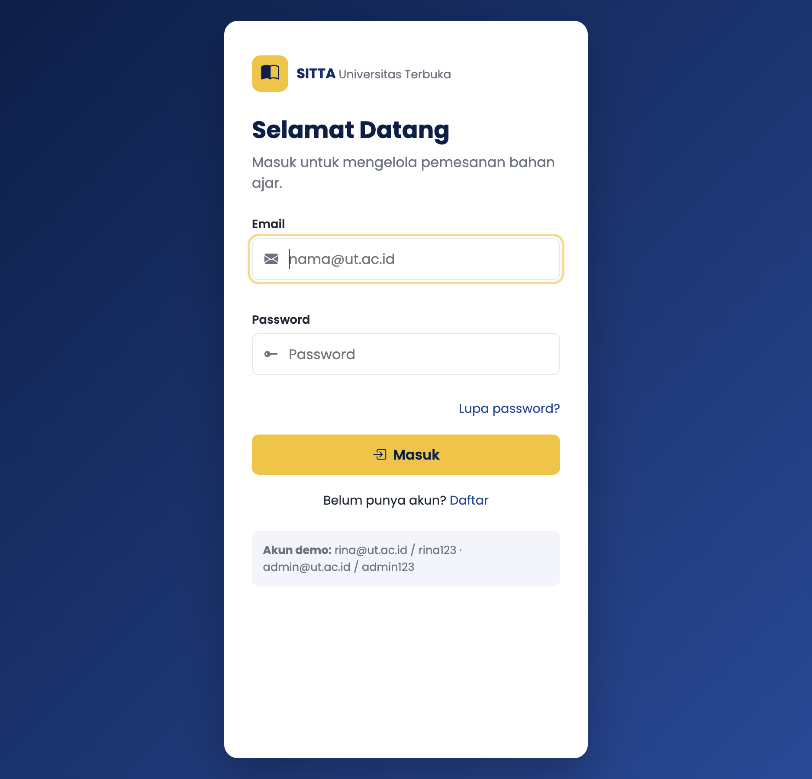
Bagian | Penjelasan
HTML | main.login-card berisi header (brand, judul), form#loginForm dengan label untuk tiap input, dan aside akun demo. Tiga modal: login gagal, lupa password, daftar
initLoginPage() | Saat submit, e.preventDefault() lalu validasi email (wajib + format regex) dan password (wajib)
Cek akun | dataPengguna.find() mencocokkan email dan password. Jika tidak ada > openModal("loginErrorModal") berisi "Email/password yang anda masukkan salah."
Login benar | Toast "Login berhasil. Selamat datang, Rina Wulandari!" lalu pindah ke dashboard.html
Lupa password | Modal; email wajib valid dan harus terdaftar, jika tidak muncul pesan "Email tidak terdaftar."
Daftar | Modal; nama, email, unit wajib diisi, password minimal 6 karakter, email tidak boleh sudah terdaftar

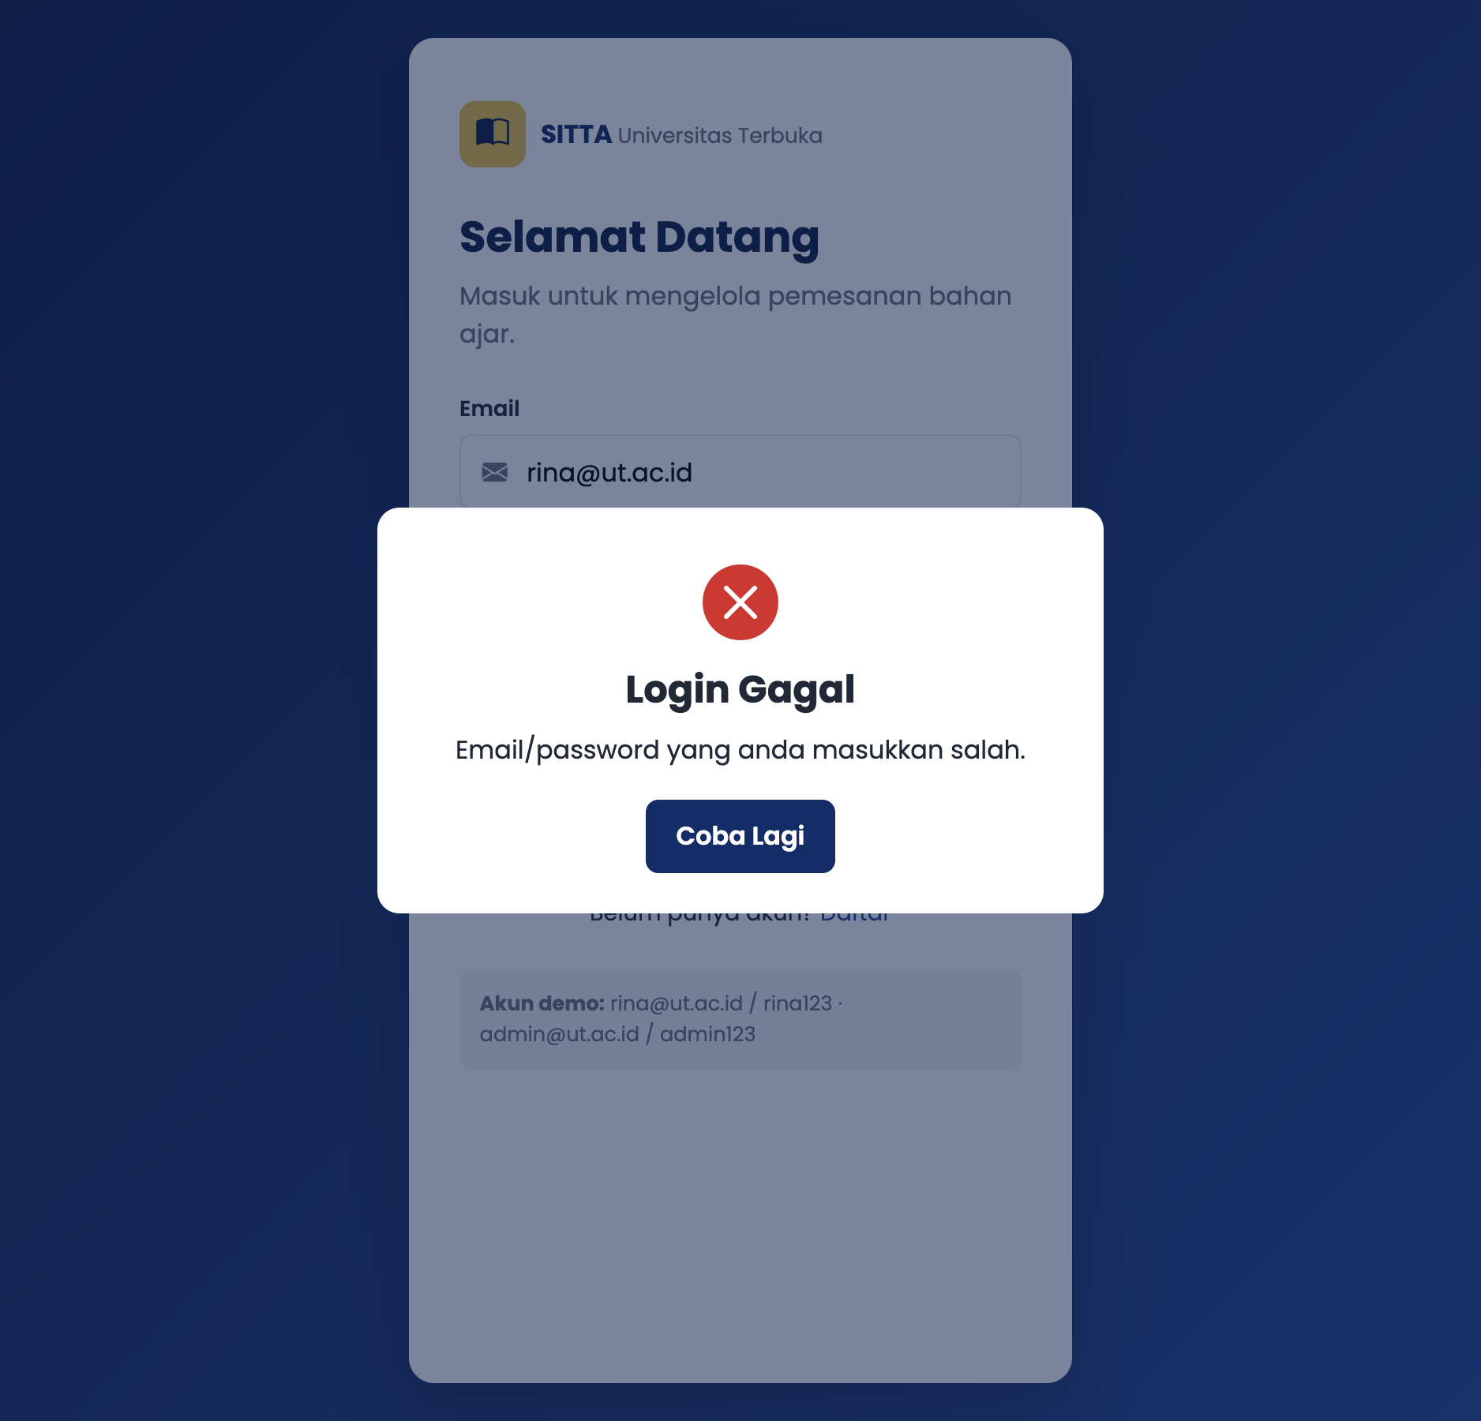
2. Dashboard (dashboard.html)
Bagian | Penjelasan
Navbar | header.navbar > nav > ul. Menu: Informasi Bahan Ajar, Tracking Pengiriman, Laporan (dropdown: Monitoring Progress DO Bahan Ajar, Rekap Bahan Ajar), Histori Transaksi Bahan Ajar, Keluar
Dropdown | Klik tombol Laporan menambah class open; klik di luar menutup dropdown
Hamburger | Di layar kecil menu disembunyikan, tombol #navToggle membuka/menutup menu
Greeting | getGreeting(jam): 04.00 sampai 10.59 "Selamat pagi", 11.00 sampai 14.59 "Selamat siang", 15.00 sampai 18.59 "Selamat sore", selain itu "Selamat malam"
Jam real-time | updateClock() dipanggil tiap 1 detik dengan setInterval, memakai toLocaleTimeString("id-ID")
Statistik | Dihitung dari data: 5 judul bahan ajar, total stok 1.587 eksemplar, 2 Delivery Order
Fitur belum ada | Menu Laporan dan Histori memunculkan toast "Fitur ... segera hadir."; tombol Keluar memakai confirm()

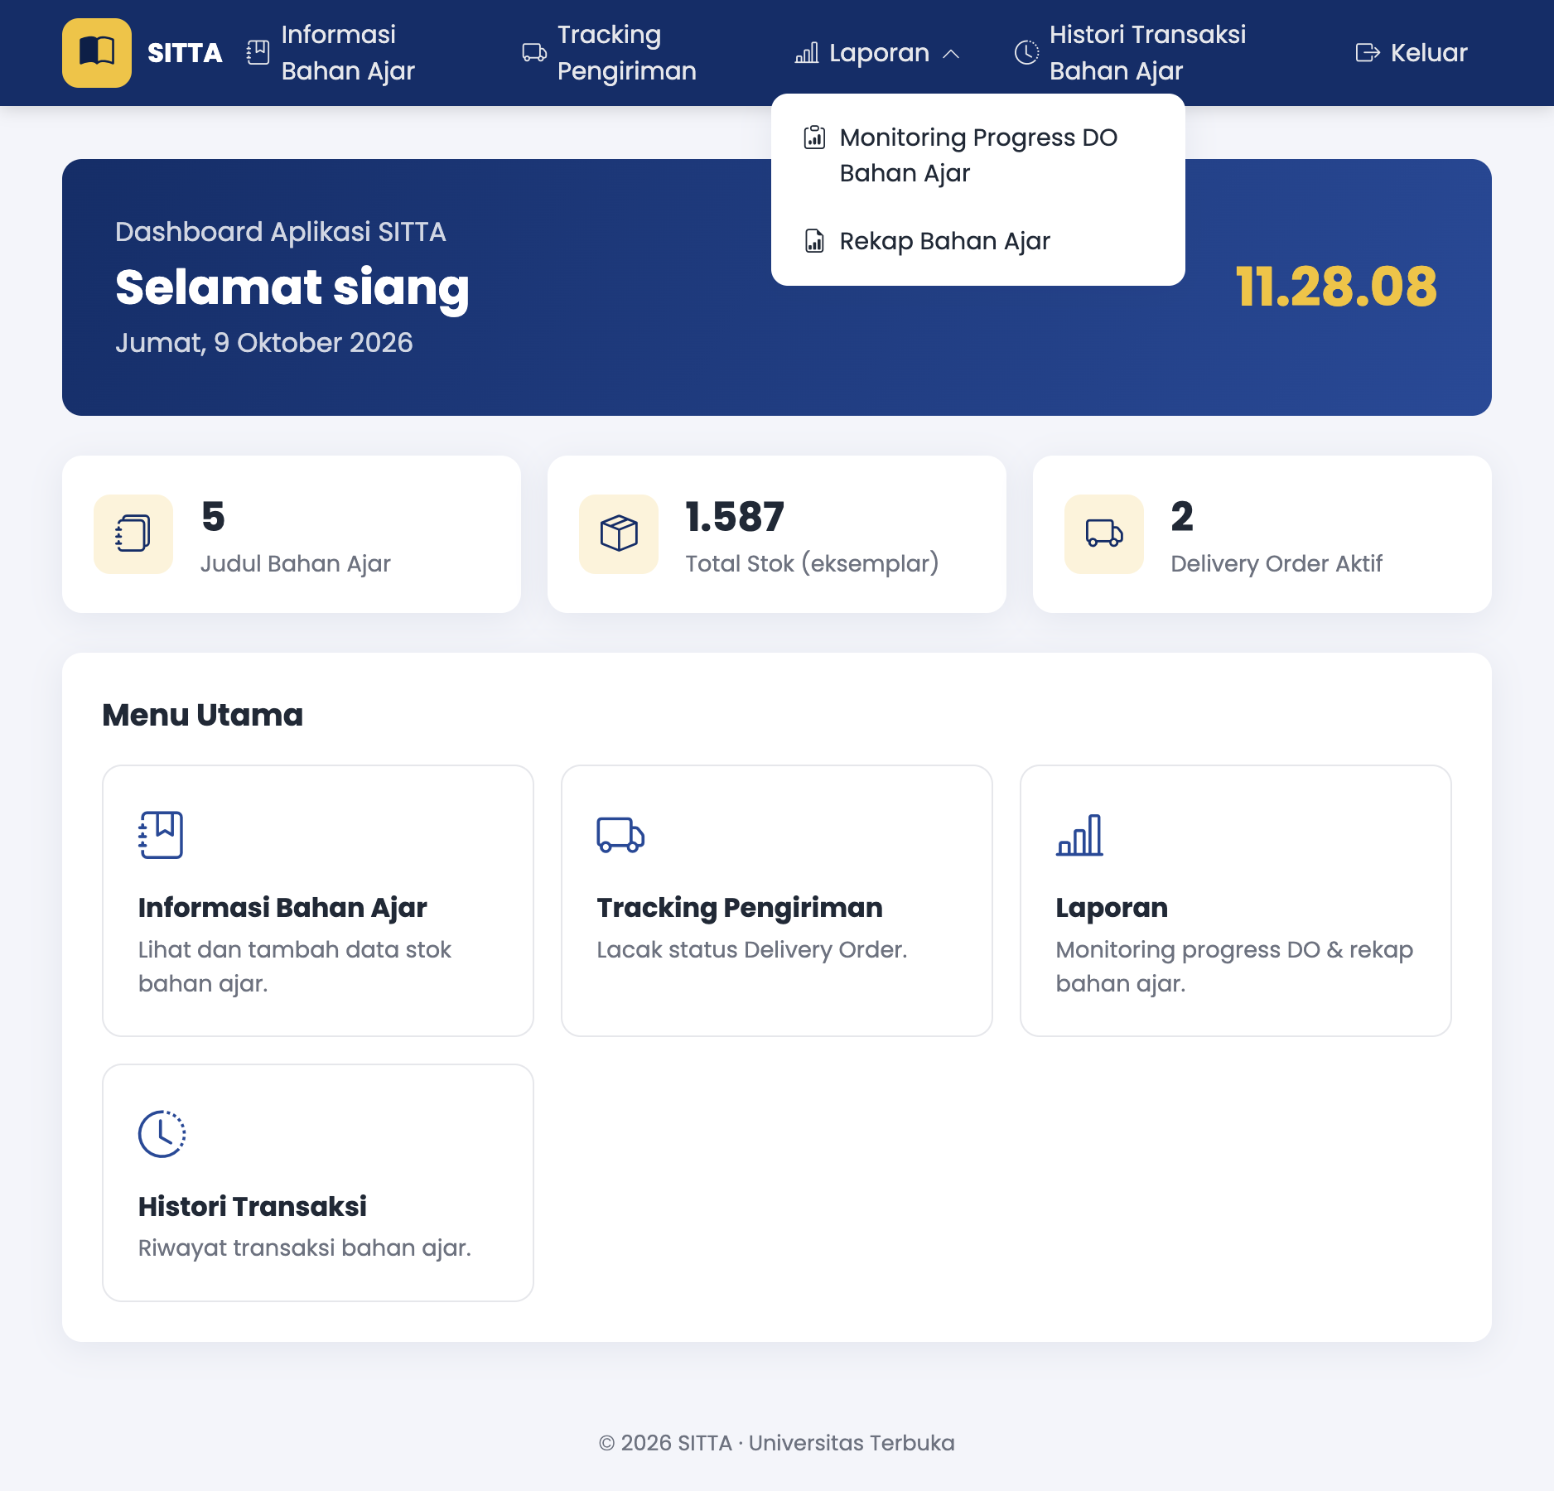
3. Tracking Pengiriman (tracking.html)
Bagian | Penjelasan
Validasi | Nomor DO wajib diisi dan hanya angka (/^\d+$/)
Cari data | dataTracking[nomor]; jika tidak ada > toast error "Nomor DO ... tidak ditemukan."
renderTracking() | Menampilkan nama mahasiswa, nomor DO, badge status, progress bar, stepper 4 tahap, detail (ekspedisi, tanggal kirim, jenis paket, total pembayaran), dan timeline perjalanan (urut terbaru di atas)
Progress | getTahapPengiriman() membaca kata kunci di keterangan log: penerimaan, hub, proses antar, selesai antar. Persen = tahap / 4 × 100
Tombol contoh DO | Mengisi input otomatis lalu form.requestSubmit()

Hasil untuk dua DO di data.js:
Nomor DO | Nama | Status | Tahap terakhir | Progress
2023001234 | Rina Wulandari | Dalam Perjalanan | Tiba di Hub (tahap 2) | 50%
2023005678 | Agus Pranoto | Selesai | Selesai Antar (tahap 4) | 100%

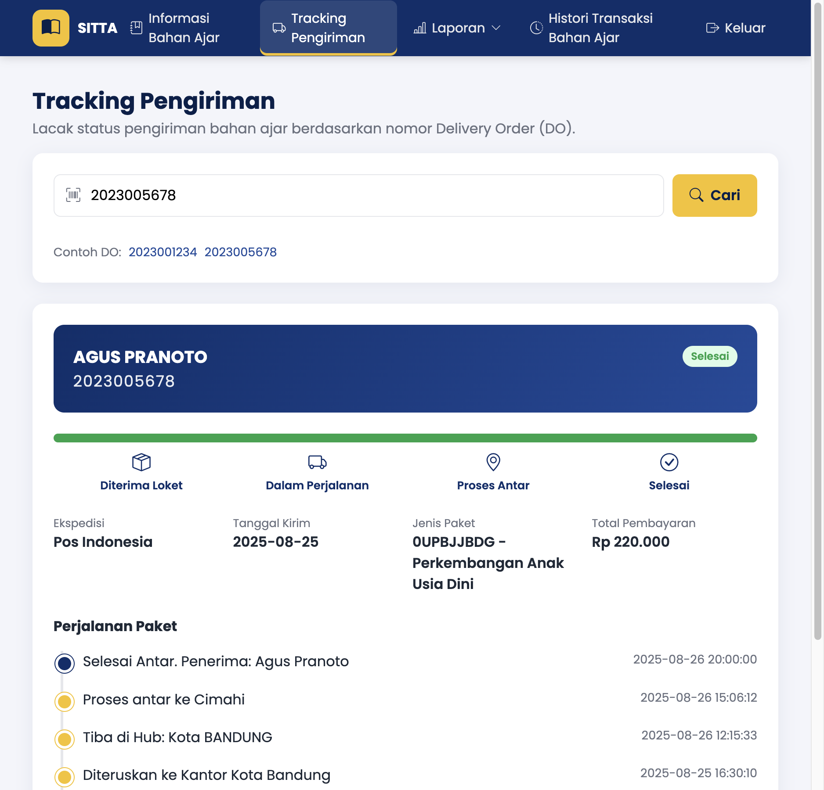
4. Informasi Stok Bahan Ajar (stok.html)
Bagian | Penjelasan
Render tabel | renderStokTable() membuat <tr> dan <td> dengan document.createElement dari dataBahanAjar (cover, kode lokasi, kode barang, nama, jenis, edisi, stok)
Badge stok | Stok di bawah 200 diberi badge merah "Stok menipis" (Mikrobiologi Dasar, 165), selain itu hijau
Pencarian live | Event input pada kotak cari menyaring berdasarkan kode barang, nama, atau kode lokasi
Tambah stok | Modal form; data baru di-push ke dataBahanAjar, tabel dirender ulang, baris baru disorot
Validasi tambah | Kode lokasi 4 sampai 10 huruf/angka; kode barang format 4 huruf + 4 angka dan tidak boleh duplikat; nama dan jenis wajib; edisi bilangan bulat minimal 1; stok bilangan bulat minimal 0
Ringkasan | Teks di bawah tabel: jumlah data yang tampil dan total stok

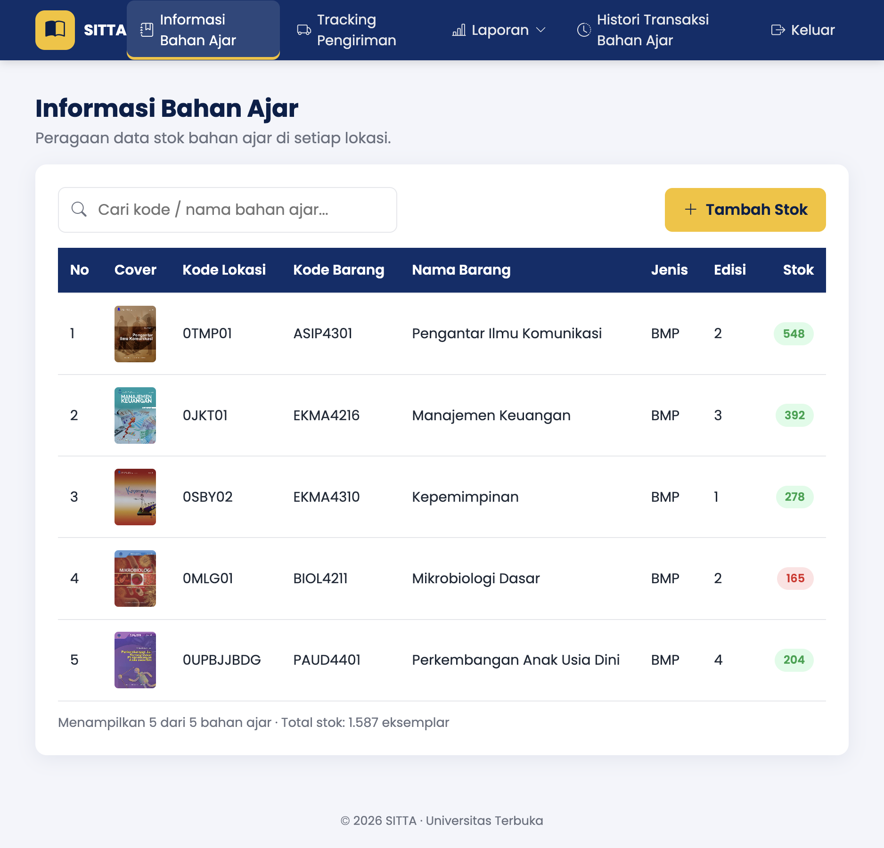
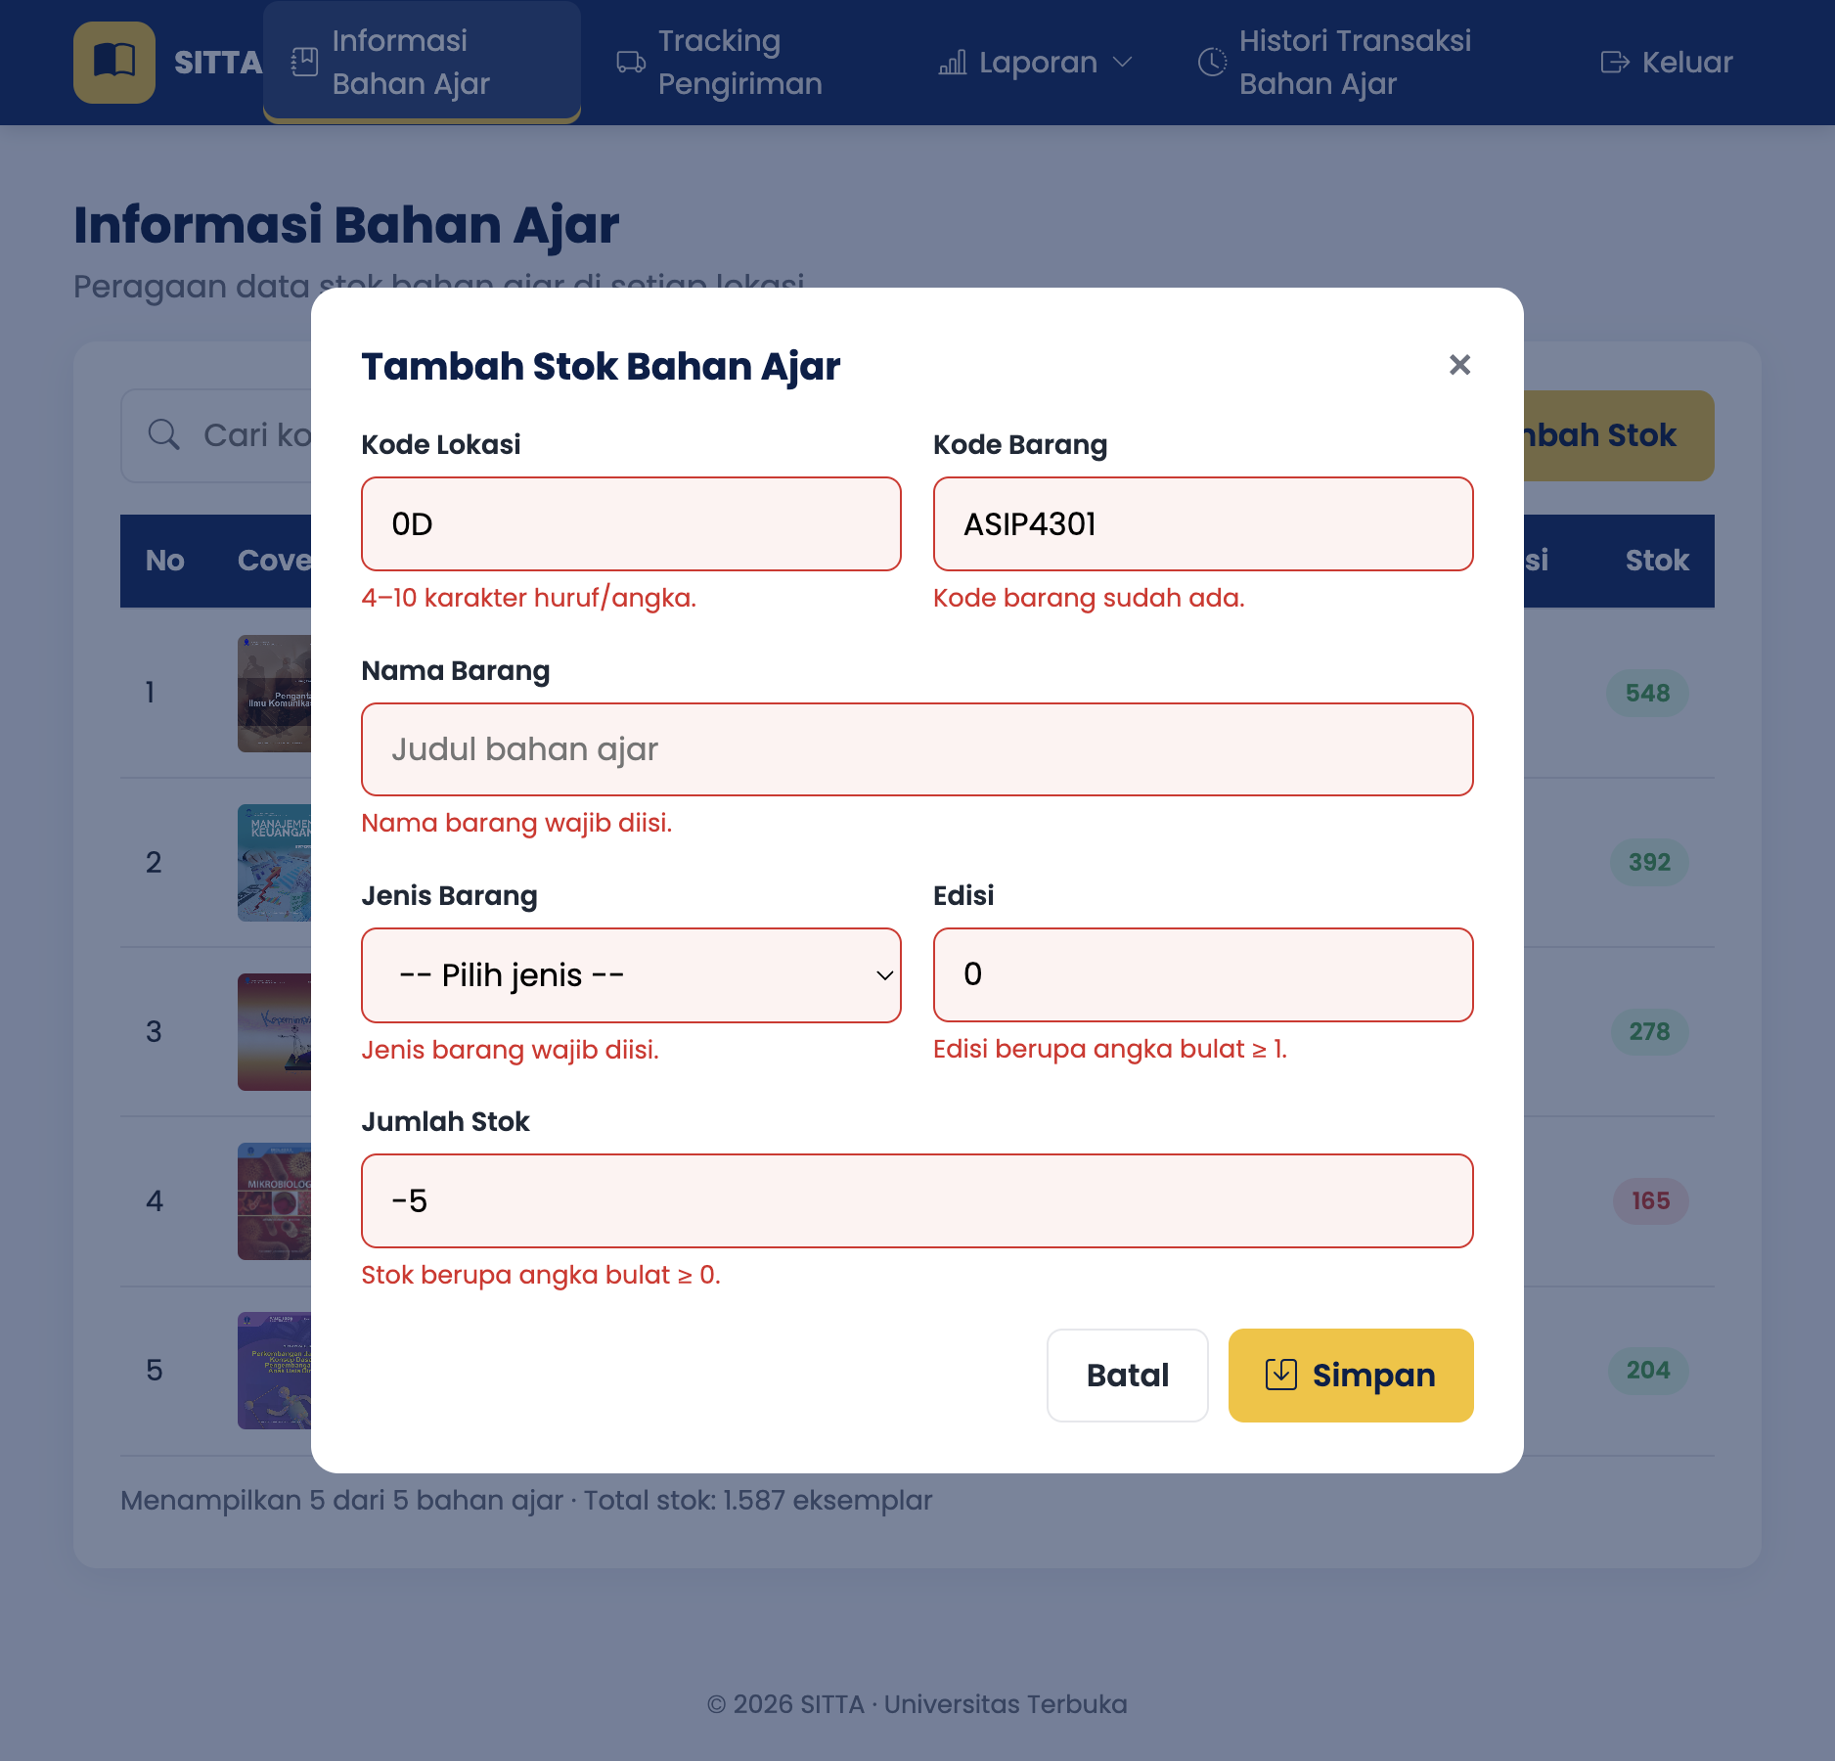
Pemetaan ke kriteria penilaian
Kriteria | Implementasi
1.1 HTML semantik | header, nav, main, section, article, aside, footer, dl, time, table dengan thead dan th scope, label for, atribut aria-*, lang="id"
1.2 CSS | External css/style.css untuk semua halaman; internal <style> di tracking.html (header DO, progress bar, stepper, timeline); inline style="" pada beberapa elemen; CSS variables, flex/grid, animasi, media query
1.3 JavaScript DOM | Render tabel stok, tambah baris, pencarian live, render hasil tracking, greeting dan jam real-time, statistik dashboard, dropdown dan hamburger menu
1.4 Validasi & alert | Validasi semua form dengan pesan error di bawah input, modal login gagal, toast sukses/gagal, confirm() saat keluar
1.5 Modularitas | HTML, CSS, JS, data, dan gambar dipisah per folder sesuai struktur soal; script.js dipecah per fungsi dan per halaman
1.6 Kreativitas | Tema warna navy dan kuning UT, Bootstrap Icons, toast notification, stepper status pengiriman, badge stok menipis, tampilan responsive untuk mobile, tombol contoh DO

Cuplikan tiga jenis CSS
External (css/style.css), variabel warna tema:
:root {
--navy: #0b2e6b;
--yellow: #f6c21c;
--success: #16a34a;
--danger: #dc2626;
--radius: 12px;
}

Internal (<style> di tracking.html), progress bar pengiriman:
.progress-bar {
height: 100%;
width: 0;
background: var(--yellow);
transition: width 0.8s ease;
}

Inline (index.html):
<span>SITTA <small style="font-weight: 400; color: #6b7280">Universitas Terbuka</small></span>

Perbaikan data.js
• dataTracking["2023005678"].nomorDO sebelumnya "2023001234" (dobel), diperbaiki menjadi "2023005678", dan status menjadi "Selesai" karena log terakhir "Selesai Antar".
• Waktu log ke-3 DO 2023001234 sebelumnya sama dengan log pertama (10:12:20), diubah menjadi 16:45:10 supaya urut.
• Path cover img/... diubah menjadi assets/img/... sesuai struktur folder; cover PAUD memakai ekstensi .jpeg sesuai file aslinya.
- Bukti Video dengan Link Youtube
Link YouTube: (isi link YouTube, mode Public atau Unlisted)
Link Google Drive: (isi link Google Drive, akses "Anyone with the link")
Catatan (hapus setelah dicek): durasi maksimal 15 menit; video wajib menampilkan wajah; di awal sebutkan Nama, NIM, Program studi (Sistem Informasi), dan Mata kuliah STSI4209; jelaskan alur berpikir dan struktur file, demo semua halaman (login salah dan benar, dashboard, tracking, stok tambah valid dan tidak valid), jelaskan hasil, lalu penutup singkat.
- Tangkapan Layar (Screenshot) Swafoto Bersama Layar Program
Simpan foto selfie bersama layar aplikasi SITTA yang sedang berjalan sebagai web-programming/laporan-img/swafoto-layar-program.png lalu generate ulang, atau tempel langsung di Word.
[Gambar belum ada: Swafoto bersama layar program (./laporan-img/swafoto-layar-program.png)]
DAFTAR PUSTAKA
Sufandi, U. U. (2022). Analisis kebutuhan dan dokumentasi sistem informasi tiras dan transaksi bahan ajar Universitas Terbuka. Jurnal Nasional Pendidikan Teknik Informatika: JANAPATI, 11(2), 112-122. https://doi.org/10.23887/janapati.v11i2.42966
Sufandi, U. U., Aprijani, D. A., & Pandiangan, P. (2021). Evaluasi dan hasil review desain user interface prototype aplikasi mobile SITTA Universitas Terbuka. Jurnal Nasional Pendidikan Teknik Informatika: JANAPATI, 10(3), 147-156. https://doi.org/10.23887/janapati.v10i3.40281
W3Schools. (n.d.). How to create a dropdown navbar. https://www.w3schools.com/howto/tryit.asp?filename=tryhow_css_dropdown_navbar
W3Schools. (n.d.). How to create a modal box. https://www.w3schools.com/howto/howto_css_modals.asp
W3Schools. (n.d.). How to create a popup form. https://www.w3schools.com/howto/howto_js_popup_form.asp
W3Schools. (n.d.). JavaScript date methods. https://www.w3schools.com/js/js_date_methods.asp
W3Schools. (n.d.). JavaScript popup boxes. https://www.w3schools.com/js/js_popup.asp
(Opsional) Tambahkan BMP mata kuliah: Nama penulis. (tahun). *Judul BMP* (Edisi). Universitas Terbuka.

